Ashley Speeney Cooperating Teachers’ Initials_____
November 17, 2006
8th Grade Algebra
Time allowed 2 - 3 class periods

Goals
- The students will be able to differentiate where the slope is positive, negative, and steepness of certain areas.
Specific Objectives
- The students will be able to identify what positive and negative slopes look like given a drawing or picture to 100% accuracy.
- The students will be able to reason why a given equation will accurately fit a certain slope.
- The students will be able to navigate through NASA World Wind given the appropriate set of directions in order to get to the desired place in the United States.
- The students will be able to compare different sites in the United States.
- The students will relate from their comparisons how the slope of terrain is used possibly in daily life activities, hobbies, weather, etc.

PA Standards

Mathematics Standards
2.5.8C Justify strategies and defend approaches used and conclusions reached
2.7.8D Compare and Contrast results from observations and mathematical models
2.8.8C Create and interpret expressions, equations, or inequalities that model problem situations
2.8.8F Solve and graph equations and inequalities using scientific and graphing calculators and computer spreadsheets

Science and Technology Standards
3.5.10A Relate earth features and processes that change the earth
3.7.10C Apply basic computer operations and concepts

I recognize I have students with special needs and there will be modifications made to the lesson.

Teacher Materials
- Satellite Picture
- Topography Picture
- Mountain Picture
- Student worksheet (one for each student)
- Answer Key for the student worksheet (Possible answers, the teacher should do this before the lesson is done, because with construction and rebuilding the world is changing constantly.)
- Calculator
- Chalk
- Eraser
- Hand out of the functions of World Wind
- Field Trip forms and release forms (one for each student)
- Answer Sheet for each student to record their answers

Student Materials
- Paper
- Pencil
- Graphing Calculators (one for each student)

Prerequisite Skills
- The students should be knowledgeable on basic computer functions.
- The students should be familiar with a basic knowledge of what slope is.
- The students should know how to input a function into a calculator to get a graph of a specific function.

Procedures
Motivation
The teacher should begin the lesson by asking the students if they have ever seen the attached satellite picture, number 1. If the students have, ask them where they have seen it before. After this, the teacher should show the picture of the topography map, number 2. The teacher should tell the students that a topography map is used to show a raised detailed description of a certain area. (The students may have seen a topography map in a history class.) Next, the teacher should show the picture of the mountain range, number 3.

Development

- After the teacher shows the pictures we will begin this next part of the lesson, introducing NASA World Wind.
- The teacher should ask the students what do you think these three pictures have in common? Once the student’s guess a couple of times, the teacher will introduce them to NASA World Wind. The teacher will tell the students that they will be working with this program developed by NASA using satellites to take pictures of the earth. In this program, you can descend and ascend to look at anywhere in the world. You can also zoom in on certain cities, which have quite a clear resolution and you can actually instead of looking from above use a view in which it looks like you are looking at something to the side, as if you were standing on the street.
- Once you tell the students this information, the teacher will tell the students to click on the icon to get into NASA World Wind.
- The teacher at this point should go over some of the basic functions that the students will be using in NASA World Wind. The teacher should pass out the hand out of the functions World Wind will allow you to do.
- Some of these are: Viewing angle and rotation, zooming in and out, and the icons located at the top of the World Wind screen.
- At this point, the teacher should let the students get acquainted with the program. The teacher can walk around to help students. Also the teacher should make sure the students know how to zoom and change angles, because this is vital for the lesson on slope.
- The teacher should have the students find these three places using the place finder icon, Denver, Colorado, Topeka, Kansas, and California, Pennsylvania. They should look at the topography of these three sites.
- The teacher should tell the students that they would be expected the next class period to find ten different locations to show the slope of the land in those areas.
- This should be the end of the first class period.
- The teacher should have the worksheets for the students sitting in the front of the room so the students can pick them up as they come in the room.
- During this class period, the students should get on NASA World Wind and begin the worksheet that the teacher left in the front of the room. The worksheet is self-explanatory. However, the teacher should walk around the room to aid the students in any way. Remind the students to refer to the hand out on the functions of World Wind if they need help with that aspect.
- During this class period, the students should do the entire worksheet. If the students do not get finished this period, they should have almost completed the entire worksheet.
- At the end of the second day, the teacher should let the students know that they need to finish the worksheet the following day, if they aren’t done already. The worksheet will be turned in the following day.
- At the start of the third day, if you don’t need this time to finish the worksheet, then you can just skip down to where the class has a discussion about the findings and conjectures that were made.
- After the students are completely done with the worksheet the teacher should collect the work.
- Once all of the work is collected from the students, the class will have a discussion about what they learned while doing the worksheet.
- The class discussion should consist of some of the questions on the worksheet. Where did the students find an undefined slope or a slope of zero? Did the graphs on the calculators work? If they didn’t, why not. What subjects did the students use to relate to NASA World Wind in the connections question? How did they use them in the examples?
- The teacher should bring the class discussion to an end as the class is about to be over. The teacher should then go over the conjectures that were made and some good points that were possibly made in the discussion.
Conclusion
After the class discussion is completed, the teacher should go over some rules for slope, which should have come up when talking about the conjectures. The teacher should conclude the class by handing out the release forms and the field trip forms to the class. Tell them when they need to be turned in by and how much it will cost to go.
Extension
In the days following the lesson, the teacher could get together a mini trip to a rock-climbing gym. Around this area, there is one in Pittsburgh called The Climbing Wall, Incorporated, which is located on Penn Avenue in Pittsburgh. The cost is twelve dollars per person. There is also a smaller gym for younger students. This would give the students some knowledge of how the slope of rock formations can be quite steep and tough to climb, even for experienced climbers. Another extension is for the students to test all of the conjectures in the experiment instead of just five.

Evaluation and Reflection

Cooperating Teachers’ Feedback

Name: ___________________ Period____________ Date________

Directions: During this experiment you will be discovering various places in the United States! You will then be choosing some places across the United States that represents different slopes. You will also be creating equations that correspond to these sites. Before you begin, make sure you have a graphing calculator and the NASA World Wind functions worksheet.

Step #1 Double Click on the NASA World Wind icon. You will need to go to search places. You will need to choose ten places in the United States where you can view the slope. This could be a building, landmark, man or nature made site, etc just to name a few. Once you have decided that you would like to choose a certain place make sure to label it on your answer sheet.
Step #2 When you view the place, you will need to take a screen capture of what you are looking at. Paste the picture in a Microsoft Word document. Label which number the screen capture goes with. Based on what you are looking at you will need to tell whether it is a positive, negative, zero, or undefined slope. (Make sure the slopes are different, not all of the same type!) Make sure you also explain, under the screen capture in Microsoft Word why you chose the type of slope you did to define it.
Step #3 On your answer sheet, write what you think the equation for the line would be using the formula y = mx + b. Also, remember to fill out the entire table information.
Step #4 After you have collected all of the data, complete the second part of the worksheet.
Name: ___________________ Period____________ Date________
Answer Sheet
PART 1
Name of the place you chose | Positive/Negative/etc slope | Y = mx + b | Did the conjecture work?
1.
2.
3.
4.
5.
6.
7.
8.
9.
10.

Test the first five equations by putting your equation in the graphing calculator to view the graph. Did the graph of your equation appear the same as the screen capture? Why or why not? (1)_____________________________________________________________________________________________________________________________________________________________________________________________________________________

(2)_____________________________________________________________________________________________________________________________________________________________________________________________________________________(3)_____________________________________________________________________________________________________________________________________________________________________________________________________________________(4)_____________________________________________________________________________________________________________________________________________________________________________________________________________________(5)_____________________________________________________________________________________________________________________________________________________________________________________________________________________

PART 2

What conjecture can you make about slope given your equations? What does the m, x, and b mean? What occurs when a slope is negative, positive, undefined, or zero?
________________________________________________________________________________________________________________________________________________________________________________________________________________________________________________________________________________________________

Based on the data you have collected in the experiment using NASA World Wind; compare some of the real world activities that use the slope of the land. How is it used in daily activities, hobbies, etc.? ________________________________________________________________________________________________________________________________________________________________________________________________________________________________________________________________________________________________________________________________________________________________________
Connections Question
Relate this form of satellite sensory to another area of school, social studies, history (past or present), chemistry, or any other. How could this technology be useful in the particular field you have just chosen? Give at least three examples of how this program could be used in that field. ________________________________________________________________________________________________________________________________________________________________________________________________________________________________________________________________________________________________________________________________________________________________________________________________________________________________________________________________________________________________________________________________________________________________________________________________________________________________________________________________________

Functions of NASA World Wind
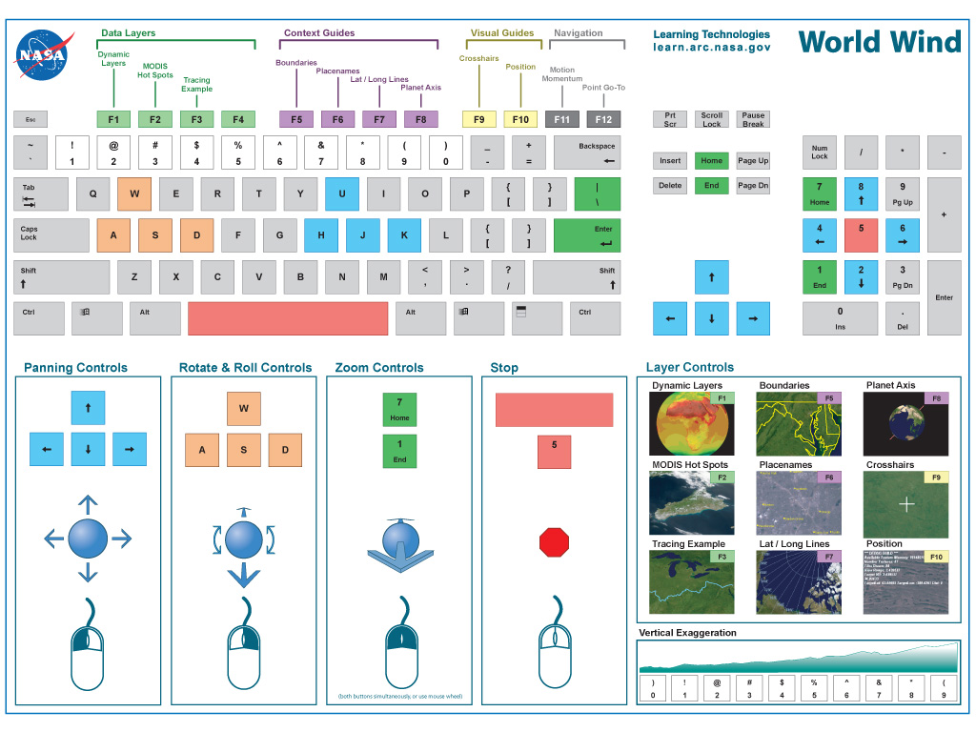

Picture Number 1

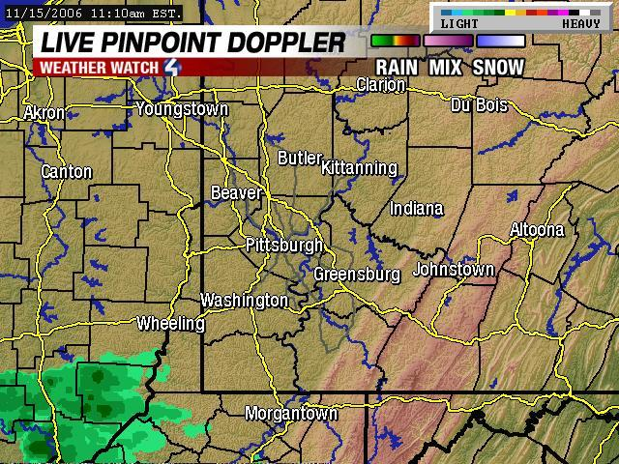

Picture Number 2

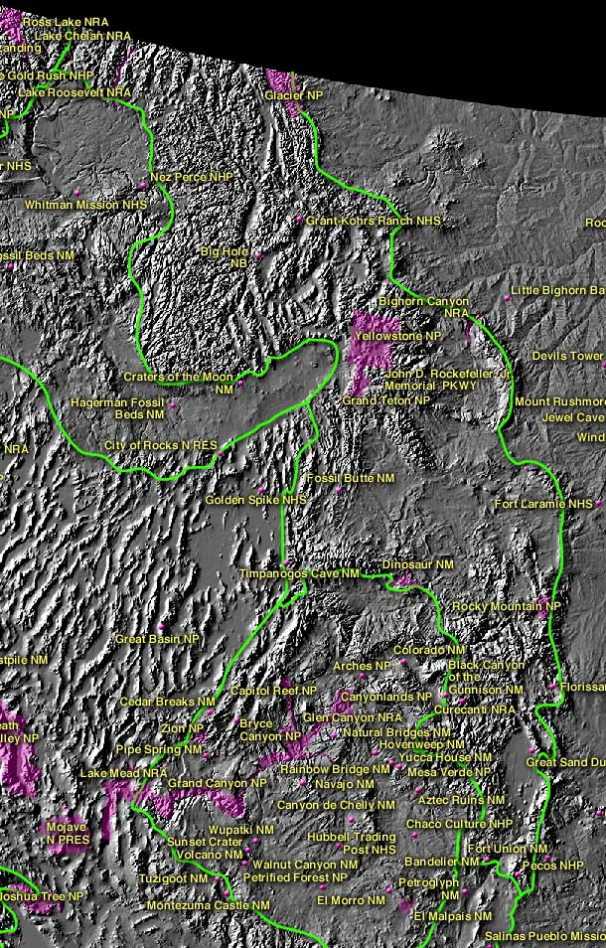
Picture Number 3

